CS610: Final exam (40%)
Due: 05/06/2018, 11:59 P.M.

No delay is accepted whatsoever. After the due date I grade the test for 0
Post your answer in the folder Final Exam on the blackboard.
You can post your answers one time only.
I cannot answer the questions to help you, but if you like to clarify anything about the questions email me at mbadii@pace.edu. In this case let me know which part of a question is not clear for you.

Write your answers in this file below the word: “Answer” and post this file only.
There are two questions.

Question 1 (OpenMP):
Write a parallel program using OpenMp to accomplish the same as the following serial program. For the following serial program the user enters a line and the program outputs the number of occurrences of each character.
For the parallel program if we have n threads we should divide the line into n segments and let each thread counts the characters of its segment.
Note: In the following program I named: n to be: thread_count
//File name: a.c
#include<stdio.h>
#include<stdlib.h>
#include <string.h>

#define ASCIIs 127 //ASCII characters from 0 to 127
#define atmost 1000

char letters[atmost + 1]; //Extra location for the string terminator '\0'
int total_count[ASCIIs];
void find(int count[], int start, int end);

int main()
{
int i, thread_count, n, start, end;
int count[ASCIIs], my_rank, segment, p;

printf("Enter a line not larger than 1000 characters.\n");
fgets(letters, atmost,stdin);

printf("How many segments?: ");
scanf("%d", &thread_count);
//To make the length of the divisible by thread_count:
while(strlen(letters) % thread_count != 0) strcat(letters, " ");

n = strlen(letters);

for(i = 0; i < ASCIIs; i++)
total_count[i] = 0;

for(p = 0; p < thread_count; p++)
{
my_rank = p;
segment = n / thread_count;
start = my_rank * segment;
end = start + segment;
find(count, start, end);

for(i = 0; i <= ASCIIs; i++)
total_count[i] += count[i];
}

for(i = 33; i < ASCIIs; i++)
if(total_count[i] != 0)
printf("Number of %c is: %d\n", i, total_count[i]);
return 0;
}

void find(int count[], int start, int end)
{
int i;
for(i = 0; i < ASCIIs; i++)
count[i] = 0;
for(i = start; i < end; i++)
count[(int)letters[i]]++;
}

For example:

Enter a line not larger than 1000 characters.
for(i = 0; i < strlen(letters); i++){
Number of ( is: 2
Number of ) is: 2
Number of + is: 2
Number of 0 is: 1
Number of ; is: 2
Number of < is: 1
Number of = is: 1
Number of e is: 3
Number of f is: 1
Number of i is: 3
Number of l is: 2
Number of n is: 1
Number of o is: 1
Number of r is: 3
Number of s is: 2
Number of t is: 3
Number of { is: 1

Answer:
Question 2 (Pthread):
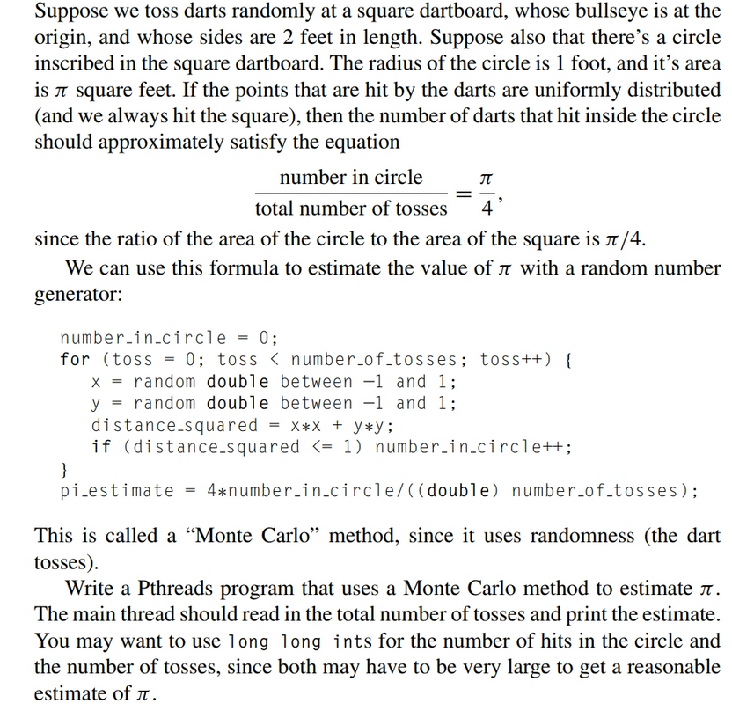

Answer:

